Exercise 1

1. Please develop a school timetable as follows:

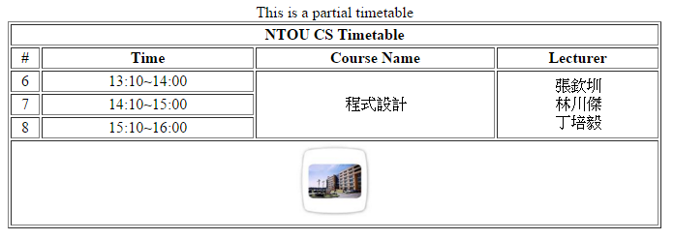

Requirements:

1. The width of the table is 50% of the screen width.
2. A small-sized image (80\*80) ntoucs.jpg is placed in the foot of the table.
3. The user can click the image to link the ntou cs website. (<http://www.cs.ntou.edu.tw>).

Hints:

1. Understand the structure of a table.
2. Understand how to use rowspan and colspan in a table.
3. <br /> is inserts a single line break (斷行).
4. Set the align attribute to "center" can center-justify the text.
5. Understand how to make an image hyperlink.
6. Please write a HTML form as follows:

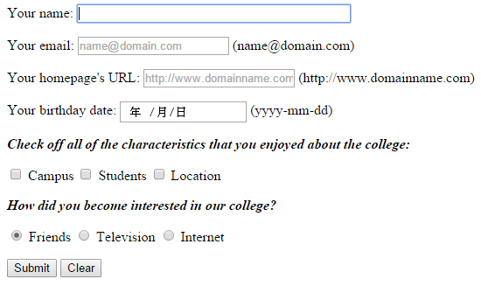

Requirements：

1. 滑鼠指標需落在「Your name」的輸入欄位中。
2. E-mail若不填寫，使用者按下submit後會出現強制輸入之訊息。
3. 若E-mail填寫錯誤的格式或Homepage填寫不對的URL (例如少了http)，使用者按下submit後會出現提示訊息。
4. Birthday可透過選取設定或直接輸入數字。
5. 單選與複選選項請按照題目要求設計，而使用者不論點選該選項之文字或checked box/radio button之按鈕，都可以選取該選項。

Hints:

1. Understand various types of HTML input elements.
2. Use <label> to group the text and its <input> element.